“**Intelligent Door Access Management System**”

A

Project report

Submitted for SmartBridge

**Submitted By:**

**Team Name:**

Keanu

Aaron Akash

Abhijeet.M. Rao

Adithya Avinash E

**Abstract**

Today the world has been far advanced in technology than in last 3 decades and with that there are advance in the technologies that help to keep our home safe. With the help of IOT now we can track our house even when we are in vacation.

The significance and the purpose of our work is to make the user’s home much safer by increasing security to and giving the user the full control of the system.

**Introduction**

**1.1 Background of Project**

When we are at work, we may have an important meeting and may not be in time to receive our guests and they may need to wait outside. The same may happen if we are on a vacation and to safe guard from Intruders.

The duty of an Engineer is to provide solution for the problems faced everyday with upcoming technologies and we have come up with a model which will help to solve it.

**1.2 Statement of the problem**

This project will create a smart doorbell messaging system so that when a guest clicks on the button, obtains an image of the user via a camera peripheral, and uploads the image and event data to a Googles Firebase cloud and sends a messaging with some message to notify that a guest has arrived.

**1.3 Aims and Objectives of the project**

The main objective of the project is to make Smart door system. The other objectives are: -

* To include an access button to allow the user to open/close the door

**Design Procedure**

**3.1 Materials**

The main components of Intelligent Door Access Management System are as follows:

**3.1.1. Raspberry pi 3**

The Raspberry Pi 3 Model B+ is the latest product in the Raspberry Pi 3 range, boasting a 64-bit quad core processor running at 1.4GHz, dual-band 2.4GHz and 5GHz wireless LAN, Bluetooth 4.2/BLE, faster Ethernet, and PoE capability via a separate PoE HAT The dual-band wireless LAN comes with modular compliance certification, allowing the board to be designed into end products with significantly reduced wireless LAN compliance testing, improving both cost and time to market. The Raspberry Pi 3 Model B+ maintains the same mechanical footprint as both the Raspberry Pi 2 Model B and the Raspberry Pi 3 Model B.

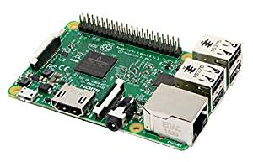

**3.1.2 Push button**

A push button is a simple type of switch that controls an action in a machine or some type of process. Most of the time, the buttons are plastic or metal. The shape of the push button may conform to fingers or hands for easy use, or they may simply be flat. It all depends on the individual design. The push button can be normally open or normally closed.

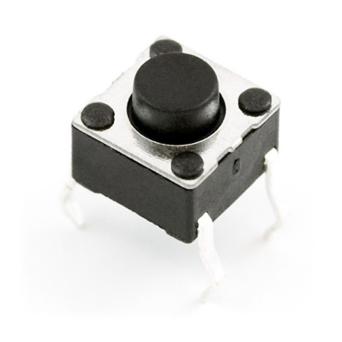

**3.1.3 Logitech Camera**

 Webcam is a [video camera](https://en.wikipedia.org/wiki/Video_camera) that feeds or [streams](https://en.wikipedia.org/wiki/Streaming_media) its image in real time to or through a [computer](https://en.wikipedia.org/wiki/Computer) to a network. The term "webcam" (a [clipped compound](https://en.wikipedia.org/wiki/Clipped_compound)) may also be used in its original sense of a [video camera](https://en.wikipedia.org/wiki/Video_camera) connected to the [Web](https://en.wikipedia.org/wiki/World_Wide_Web) continuously for an indefinite time, rather than for a particular session, generally supplying a view for anyone who visits its [web page](https://en.wikipedia.org/wiki/Web_page) over the Internet. Some of them, for example, those used as online [traffic cameras](https://en.wikipedia.org/wiki/Traffic_camera), are expensive, rugged [professional video cameras](https://en.wikipedia.org/wiki/Professional_video_camera).

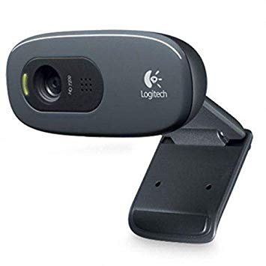

**3.1.4 Stepper motor**

Tiny and lightweight with high output power. Servo can rotate approximately 180 degrees (90 in each direction), and works just like the standard kinds but smaller. You can use any servo code, hardware or library to control these servos. Good for beginners who want to make stuff move without building a motor controller with feedback & gear box, especially since it will fit in small places. It comes with a 3 horns (arms) and hardware.

|  |  |
| --- | --- |
| Specifications | |
| Speed(s) | 0.1 |
| Torque(kg-cm) | 2.5 |
| Weight(g) | 14.7 |
| Voltage(v) | 3.3-6 |

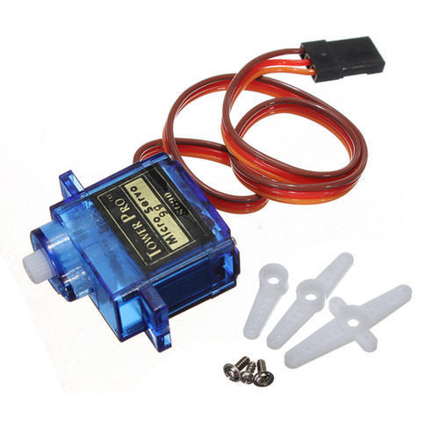

**Working**

The first step was to make an interface between the Push button and Camera using Raspberry Pi so that when the button was pressed the camera would take a picture. Next step is to connect the camera to the Firebase Cloud to upload the images in the Firebase Storage and send the image’s URL to the Firebase Database.

Next using Android Studio, a Mobile application was designed to retrieve the image from the Firebase Database. Using Node JS push messaging is also added along with the mobile app such that when some one is at the door a notification pops out. They can Open or Close the door using the buttons in the app. When pressed the data is sent to Firebase Database and retrieved by the Raspberry Pi which then operates the door.

**Flow Diagram**

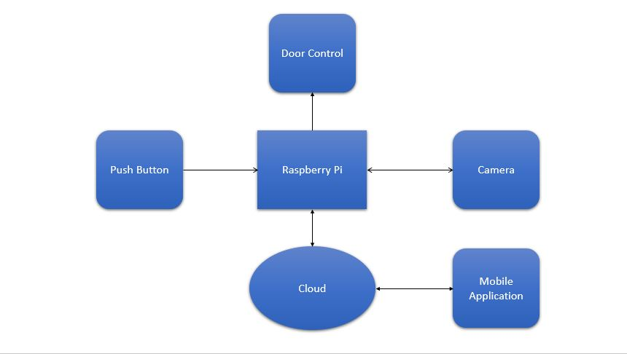

**Bill of Materials:**

|  |  |
| --- | --- |
| **Materials** | **Cost (in Rs.)** |
| Logitech camera | 1350 |
| Raspberry Pi 3B | 3500 |
| Micro Stepper motor | 400 |
| Push Button | 50 |
| Contigency | 700 |
| Total | 6000 |

**Future scope**

* Face recognition can be inmplemented to allow family members /regular guests
* It can be integrated with a burgular alarm and inform the police of intuders

**Conclusion**

The project “Intelligent Door Access Management System” has been tested real world scenario and door is opened or closed by the commands given by the user